Manufacturer
Brunner-Anliker, Swiss Made
Model
Anliker L

The latest vegetable cutter made by Brunner-Anliker! State-of-the-art materials and technology ensure highest reliability and availability in restaurants, snack bars, catering industry, and in institutions and hospitals where the main focus is on hygiene.

Tender specification
Design | - Removable top and cutting discs made of antimicrobial fiberglass composite  - Top and plunger can be removed without tools and are absolutely dishwasher-safe  - The ergonomically optimized 45-degree angle allows the operator to work in an upright position  - Switchless operation  - Average cutting performance of 220 kg/h  - Automatic safety shut-down when the plunger is open  - Extra protection by micro-fuse  - The maintenance-free induction motor comes with a 5-year guarantee on motor and gearing
Function | Cutting, shredding, grating and grinding in 40 different ways
Capacity | Up to 220 Kg/h
Motor | Induction motor 0.26 kW
Voltage | 230 V, 50 Hz, (231.01907)  230 V, 50 Hz, (231.01901)  115 V, 60 Hz, (231.01900)  240 V, 50 Hz, (231.01902)  230 V, 50 Hz, (231.01903)  115 V, 60 Hz, (231.01905)  115 V, 60 Hz, (231.01904)  100 V, 50/60Hz, (231.01906)
Space requirements | 250 x 315 x 540 mm
Noise | 40 dB
Weight | 19 kg
Certificates | CE, CSA, UL, TÜV
Design and dimensions (in cm): | 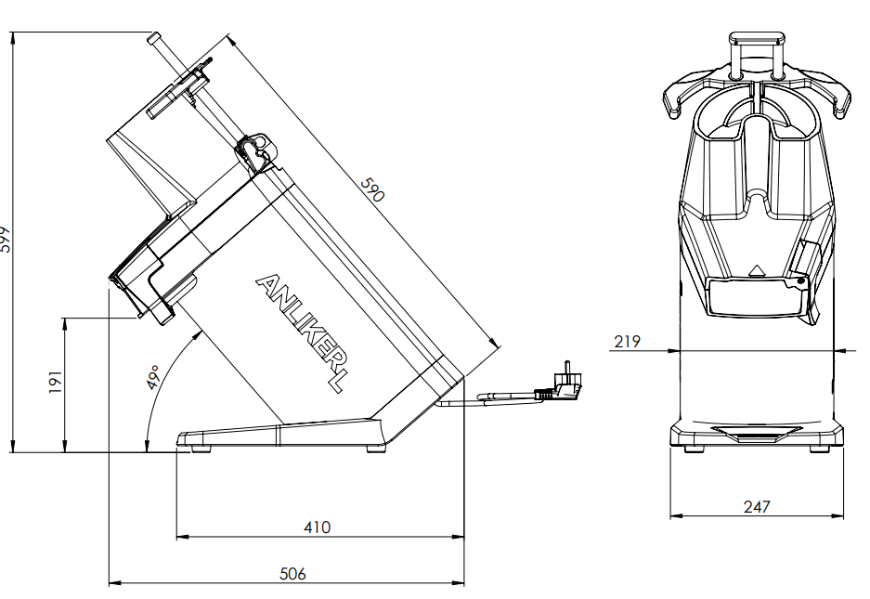

Accessories

Double Shot Set
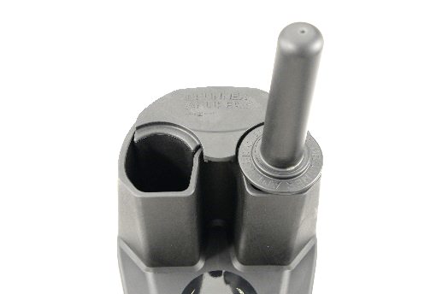
Insert for continuous feeding made of fiberglass composites; incl. standard plunger.

Recommended standard disc set

Star Kit (5 discs)
Fine cut 1 mm | F1
Rough cut 3 mm | G3
Tomato cut 5 mm | TO
Juliennes 2 mm | S2
Grating disc for hash browns | Nr. 0

Disc overview

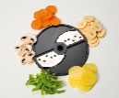 | Fine cut | Art. Nr.
Fine cut 1 mm | F1 | 232.01801
Fine cut 2 mm | F2 | 232.01802
 | Allumettes | Art. Nr.
Allumettes 4 mm | PA 4 | 232.01831
Allumettes 4 mm (cheese) | PA 4 K | 232.01832
Allumettes 5 mm | PA 5 | 232.01833
Allumettes 6 mm | WS | 232.01836

Disc holder
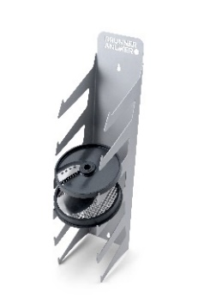
Disc holder for 6 cutting discs / 180 mm

 | Sickle knife
Sickle knife 1.5 mm | SM 1.5 | 232.01815
Sickle knife 2.5 mm | SM 2.5 | 232.01816
Sickle knife 3.5 mm | SM 3.5 | 232.01817
Sickle knife 4.5 mm | SM 4.5 | 232.01818
Sickle knife 5.5 mm | SM 5.5 | 232.01819
Sickle knife 6.5 mm | SM 6.5 | 232.01820

 | Juliennes | Art. Nr.
Juliennes 1.5 mm | S 1.5 | 232.01822
Juliennes 2 mm | S 2 | 232.01823
Juliennes 3 mm | S 3 | 232.01824
Juliennes 8 mm | S 8 | 232.01826
Juliennes 12 mm | S 12 | 232.01827
Juliennes 16 mm | S 16 | 232.01828

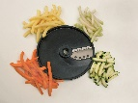 | Bâtonnets | Art. Nr.
Bâtonnets 6 mm | BT 6 | 232.01852
Bâtonnets 7 mm | BT 7 | 232.01853
Bâtonnets 8 mm | BT 8 | 232.01854
Bâtonnets 10 mm | BT 10 | 232.01855

 | Tomato cut | Art. Nr.
Tomato cut 5 mm | TO | 232.01814
 | Rough cut | Art. Nr.
Rough cut 3 mm | G3 | 232.01803
Rough cut 4 mm | G4 | 232.01804
Rough cut 6 mm | G6 | 232.01809
Rough cut 8 mm | G8 | 232.01806
Rough cut 10 mm | G10 | 232.01807
Rough cut 12 mm | G12 | 232.01808
Rough cut 20 mm | G20 | 232.01812

 | Shaving cut | Art. Nr.
Shaving cut 0.5mm | HS | 232.01821

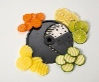 | Demidov | Art. Nr.
Demidov 5 mm | SU 5 | 232.01843
Demidov 7 mm | SU 7 | 232.01844

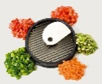 | Cubes | Art. Nr.
Cubes 6 mm | W 6 | 232.01326
Cubes 8 mm | W 8 | 232.01327
Cubes 10 mm | W 10 | 232.01328
Cubes 14 mm | W 14 | 232.01329
Cubes 20 mm | W 20 | 232.01333
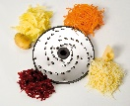 | Grating discs | Art. Nr.
Grating disc 13 mm | No 000 | 232.01931
Grating disc 11 mm | No. 00 | 232.01930
Grating disc 9 mm | No. 0 | 232.01900
Grating disc 7 mm | No. 1 | 232.01901
Grating disc 6 mm | No. 2 | 232.01902
Grating disc 5 mm | No. 3 | 232.01903
Grating disc 4.2 mm | No. 4 | 232.01904
Grating disc 3.8 mm | No. 6 | 232.01906
Grating disc 3 mm | No. 7 | 232.01907
Grating disc 2.5 mm | No. 9 | 232.01909
Grating disc 2.25 mm | No. 10 | 232.01910
Grating disc 2 mm | No. 11 | 232.01911
Grating disc 1.8 mm | No. 12 | 232.01912
Grating disc 1.5 mm | No. 13 | 232.01913
Parmesan | No. 14 | 232.01914
Curly 4 mm | No. 17 | 232.01917
Fondue 16 mm | No. 19 | 232.01919
Universal 2.5 mm | No. 23 | 232.01923
Nuts fine 2 mm | No. 24 | 232.01924

