Manufacturer
Brunner-Anliker, Swiss Made
Model
GSM5 Star

The ideal vegetable cutter with up to 50 different cutting options for restaurants, catering businesses, cruise ships, canteens, nursing homes and hospitals, and an output of up to 300 meals.
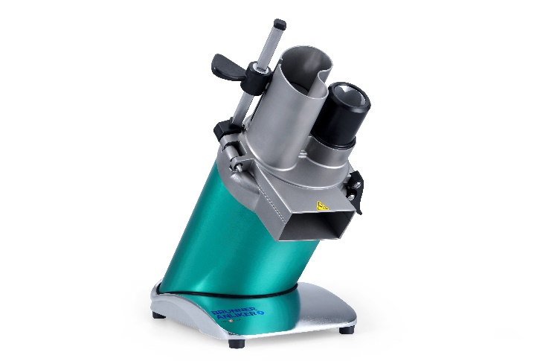

Tender specification
Design | - Cast entirely of high-grade stainless steel; HACCP-compliant  - Rotating filler neck on the right for the cutting of Brunoises and Gaufrettes  - Tool-free removal of top and plunger  - Carry handle on the back  - Electric cable 2.5 m long  - The ergonomically optimized 45-degree angle allows the operator to work in an upright position  - Average cutting performance of 150 kg/h  - Automatic safety shut-down when the plunger is open  - Extra protection by micro-fuse  - The maintenance-free induction motor comes with a 5-year guarantee on motor and gearing
Function | Cutting, shredding, grating and grinding in up to 50 different ways
Capacity | Up to 150 Kg/h
Motor | Induction motor 0.26 kW
Voltage | 230 V, 50 Hz, (231.01801)  230 V, 50 Hz, (231.01803)  230 V, 50 Hz, (231.01810)  230 V, 60 Hz, (231.01814)  220V, 60 Hz, (231.01833)  115 V, 60 Hz, (231.01836)  115 V, 60 Hz, (231.01831)  230 V, 50 Hz, (231.01839)  230 V, 50 Hz, (231.01821)  230 V, 50 Hz, (231.01823)  230 V, 50 Hz, (231.01811)  230 V, 60 Hz, (231.01815)  220V, 60 Hz, (231.01834)  115 V, 60 Hz, (231.01832)
Space requirements | 250 x 315 x 525 mm
Noise | 40 dB
Weight | 21.5 kg
Certificates | CE, CSA, UL
Design and dimensions (in cm): | 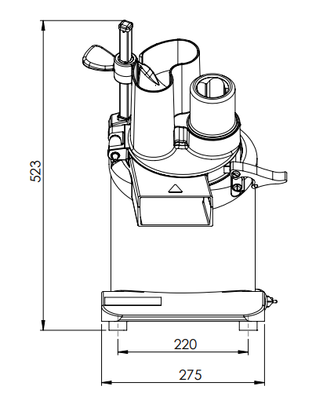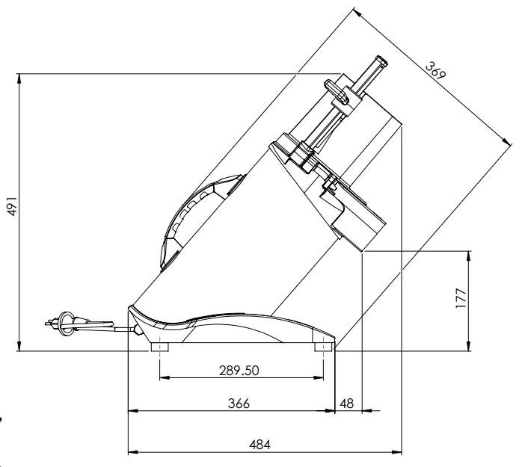

Accessories

Holder box
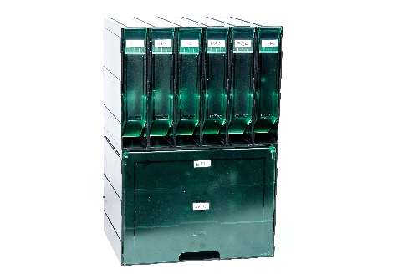
Holder box B2; consists of 6 small and 1 big box
for cutting discs Ø 180 mm

Recommended standard disc set

Star Kit (5 discs)
Fine cut 1 mm | F1
Rough cut 3 mm | G3
Juliennes 2 mm | S2
Grating disc for hash browns | Nr. 0
Brunoises 3 mm | BR3
Turning plunger GSM5 Star

Disc overview

 | Fine cut | Art. Nr
Fine cut 1 mm | F1 | 232.01801
Fine cut 2 mm | F2 | 232.01802

 | Rough cut
Rough cut 3 mm | G3 | 232.01803
Rough cut 4 mm | G4 | 232.01804
Rough cut 6 mm | G6 | 232.01809
Rough cut 8 mm | G8 | 232.01806
Rough cut 10 mm | G10 | 232.01807
Rough cut 12 mm | G12 | 232.01808
Rough cut 20mm | G20 | 232.01812

Turning plunger
Turning plunger for vegetable cutter
GSM5 Star Ø 180 mm

 | Sickle knives | Art. Nr.
Sickle knife 1.5 mm | SM 1.5 | 232.01815
Sickle knife 2.5 mm | SM 2.5 | 232.01816
Sickle knife 3.5 mm | SM 3.5 | 232.01817
Sickle knife 4.5 mm | SM 4.5 | 232.01818
Sickle knife 5.5 mm | SM 5.5 | 232.01819
Sickle knife 6.5 mm | SM 6.5 | 232.01820

 | Juliennes | Art. Nr
Juliennes 1.5 mm | S 1.5 | 232.01822
Juliennes 2 mm | S 2 | 232.01823
Juliennes 3 mm | S 3 | 232.01824
Juliennes 8 mm | S 8 | 232.01826
Juliennes 12 mm | S 12 | 232.01827
Juliennes 16 mm | S 16 | 232.01828

 | Allumettes | Art. Nr
Allumettes 4 mm | PA 4 | 232.01831
Allumettes 4 mm (cheese) | PA 4 K | 232.01832
Allumettes 5 mm | PA 5 | 232.01833
Allumettes 6 mm | WS | 232.01836

 | Brunoises | Art. Nr
Brunoises 2 mm | BR 2 | 232.01838
Brunoises 3 mm | BR 3 | 232.01839
Brunoises 4 mm | BR 4 | 232.01840
Brunoises 5 mm | BR 5 | 232.01841
 | Demidov | Art. Nr
Demidov 5 mm | SU 5 | 232.01843
Demidov 7 mm | SU 7 | 232.01844

 | Bâtonnets | Art. Nr
Bâtonnets 6 mm | BT 6 | 232.01852
Bâtonnets 7 mm | BT 7 | 232.01853
Bâtonnets 8 mm | BT 8 | 232.01854
Bâtonnets 10 mm | BT 10 | 232.01855
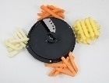 | French fries | Art. Nr
French fries 10 mm | PF 10 | 232.01857

 | Tomato cut | Art. Nr
Tomato cut 5 mm | TO | 232.01814

 | Shaving cut | Art. Nr
Shaving cut 0.5mm | HS | 232.01821

 | Gaufrettes | Art. Nr
Gaufrettes 2 mm | PG2 | 232.01856
Gaufrettes 4 mm | PG4 | 232.01848
Gaufrettes 6 mm | PG6 | 232.01849

 | Cubes | Art. Nr
Cubes 6 mm | W 6 | 232.01326
Cubes 8 mm | W 8 | 232.01327
Cubes 10 mm | W 10 | 232.01328
Cubes 14 mm | W 14 | 232.01329
Cubes 20 mm | W 20 | 232.01333

 | Grating discs | Art. Nr
Grating disc 13 mm | No 000 | 232.01931
Grating disc 11 mm | No. 00 | 232.01930
Grating disc 9 mm | No. 0 | 232.01900
Grating disc 7 mm | No. 1 | 232.01901
Grating disc 6 mm | No. 2 | 232.01902
Grating disc 5 mm | No. 3 | 232.01903
Grating disc 4.2 mm | No. 4 | 232.01904
Grating disc 3.8 mm | No. 6 | 232.01906
Grating disc 3 mm | No. 7 | 232.01907
Grating disc 2.5 mm | No. 9 | 232.01909
Grating disc 2.25 mm | No. 10 | 232.01910
Grating disc 2 mm | No. 11 | 232.01911
Grating disc 1.8 mm | No. 12 | 232.01912
Grating disc 1.5 mm | No. 13 | 232.01913
Parmesan | No. 14 | 232.01914
Curly 4 mm | No. 17 | 232.01917
Fondue 16 mm | No. 19 | 232.01919
Universal 2.5 mm | No. 23 | 232.01923
Nuts fine 2 mm | No. 24 | 232.01924
Tempura 2 mm | No. 26 | 232.01926

